1. **Initialize a new repository. Add two files in your working directory.**

1. **View the changes in the working directory and the staging area.**

**{Files are untouched and not being tracked}**

1. **Stage both files**

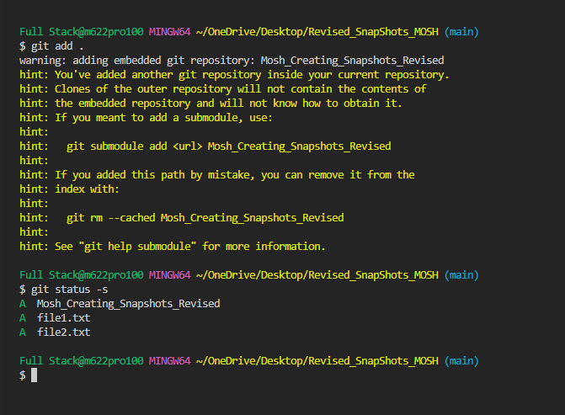

1. **View the changes in the staging area.**

5. **Create commit.**

1. **View the list of commits**

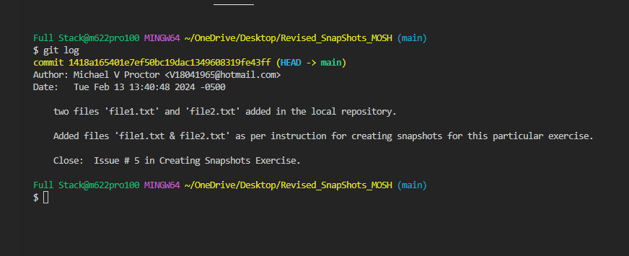

1. **View the content of the last commit.**

1. **Update one of the files. View the changes in the working directory.**

Update one of the files. View the changes in the working directory.

Un-stage the file.

Commit made to file1. Txt and file staged

1. **Un-Stage the file.**

